CERTIFICATE

This is to certify that the project entitled

ThoughtCircle

A full stack social media web application integrated with sentiment Analysis has been successfully completed by

RUPESH KUMAR 20232732

under the guidance of Dr. Subodh Kumar and Mr. Sumit Kumar, in partial fulfillment of the requirements for the degree of

B.Voc Software Development
from

Ramanujan College, University of Delhi

This project report is a genuine record of the work carried out by the above student during the academic year 2025-2026.

Project Guide Head of Department

Signature : _________________ Signature : _____________

Name : Dr. Subodh Kumar / Mr. Sumit Kumar Name : Dr. Sahil Pathak

(Professor) (Professor)

Project Overview
In the digital era, social media has become one of the most influential platforms for communication, interaction, and content sharing. With users increasingly seeking personalized, interactive, and community-driven online spaces, there is a growing demand for modern social networking applications that provide seamless user experience and content-centric engagement.
ThoughtCircle is a full-fledged social media web application designed to offer users a secure, responsive, and intuitive platform where they can create posts, share thoughts, upload images, interact with peers, and build meaningful digital connections. The application focuses on simplicity, performance, and community engagement, making it an ideal space for students, professionals, and general users who wish to express ideas and connect with like-minded individuals.
The platform is developed using the MERN stack (MongoDB, Express.js, React.js, Node.js), along with Redux Toolkit for optimized state management and Cloudinary for cloud-based image storage. These technologies collectively enable robust performance, scalable infrastructure, seamless data flow, and a highly interactive user interface.
With essential features like user authentication, profile management, real-time interactions, and content feeds, the application reflects modern social media ecosystems. It also demonstrates strong foundational knowledge of full-stack development, database management, cloud integration, UI/UX design, and application architecture.
ThoughtCircle can be further enhanced with future updates such as chat systems, AI-driven recommendations, and advanced analytics, showing potential for long-term development and academic research.

Project Modules
The system is divided into 4–5 major modules, each performing a crucial function within the application:

1. User Authentication & Authorization Module
This module handles secure user registration, login, and logout functionalities. It uses JSON Web Tokens (JWT) for secure session management. Passwords are encrypted before storage to ensure data privacy. The system validates user credentials and restricts access to authorized areas of the application.

2. Post Creation & Management Module
This module enables users to create posts containing text and images. Cloudinary is used for storing image files efficiently in the cloud. Users can edit or delete their own posts. The module ensures proper formatting, validation, and organization of user-generated content.

3. Feed Module
The feed system displays posts to users in chronological order. It retrieves data efficiently using optimized API calls and Redux for global state handling. This module provides a smooth scrolling experience and supports automatic feed refresh for real-time updates.

4. User Reaction Module
Users can like or dislike posts and view interactions from other users. This module increases engagement and supports dynamic UI updates. It also implements backend logic for storing interactions in the database.

5. Sentiment Analysis Module (on Admin side)
The Sentiment Analysis Module is an advanced feature which uses Machine Learning and Natural Language Processing (NLP) techniques to classify text into predefined categories such as positive, neutral, or negative. In cases of highly negative or abusive sentiment, the content is flagged for admin review. This helps the admin take timely action, such as issuing warnings, removing harmful posts, or temporarily restricting user accounts if necessary.

Technologies Used
ThoughtCircle is built using modern industry-standard technologies for web application development:

Frontend:
- React.js : for building a responsive and component-based user interface
- Redux Toolkit : for efficient and scalable state management
- RTK Query : for seamless data fetching and automatic caching
- Tailwind CSS : for interactivity

Backend:
- Node.js : server-side runtime environment
- Express.js : backend framework for creating RESTful APIs
- JWT (JSON Web Tokens) : authentication and secure sessions
- Bcrypt : password encryption

Database:
- MongoDB : NoSQL database for scalable data storage
- Mongoose : ODM for modeling database objects

Cloud Services:
- Cloudinary : for storing and managing user-uploaded images

Development & Deployment Tools:
- Visual Studio Code
- Postman (API testing)
- Git & GitHub (version control)
- npm (package management)

Deployment Plateform :

Render : The application ThoughtCircle is deployed on Render, a modern cloud platform used for hosting full-stack web applications. Render provides automatic deployments from GitHub, secure environment variable management, scalable hosting options, and reliable uptime.

Data Flow Diagram

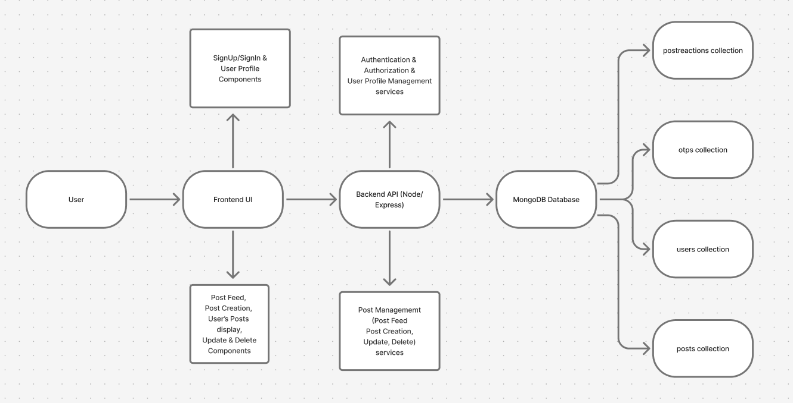

Database Architecture

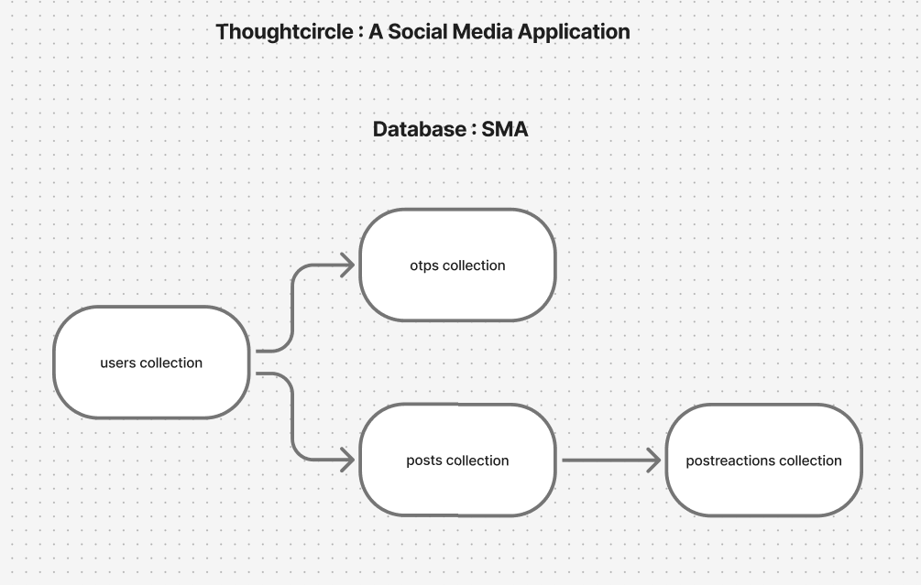

Conclusion
ThoughtCircle demonstrates the development of a functional and modern social media application using advanced full-stack technologies. The system incorporates secure user authentication, dynamic content interaction, cloud-based image storage. This project showcases strong technical knowledge, practical development skills, and the ability to design scalable, interactive applications suitable for real-world use. The platform can be expanded with additional features such as messaging, video posts, AI recommendations, or analytics, making it a foundation for future innovations.

References :
Stack Overflow : https://stackoverflow.com
Vite : https://vite.dev
React : https://react.dev/learn
Npm : https://www.npmjs.com/
Kaggle : https://www.kaggle.com/
GeeksforGeeks : https://www.geeksforgeeks.org/machine-learning/machine-learning/

Project Live Demo

https://thoughtcircle-frontend.onrender.com

Project Github Link

https://github.com/RupeshKumar4511/ThoughtCircle

https://github.com/RupeshKumar4511/sentiment-Analysis

